Walkthrough – RTB1

Contents

Host Discovery 2

Nmap 2

Nikto 2

Viewing Website 2

Dirb 3

WPScan 3

Searchsploit 3

Exploitation 3

SQLMap 3

Escalation 4

Upgrade Shell 5

Kernel Exploit 5

Flag 5

# Host Discovery

**Kali**: 192.168.56.101

**Victim**: 192.168.56.154

# Nmap







# Nikto







# Viewing Website

The main website source code reveals this data.

I can now kind of see the url structure.



# Dirb

Note: I quickly viewed the website source code before I did this scan.

# WPScan



# Searchsploit



These are 3 that I found.

This version is vulnerable to sql injection.

# Exploitation

## SQLMap

I used the credentials NickJames:admin (admin dashboard account). This got me inside the dash board.

Looking around I found nothing. I will try another account. I see George has a level 10 account.

Yes this is the account to use. He must be the website admin.

I can now put php code to establish a reverse shell, I will modify the original file hello.php.

# Escalation

Using this as a guideline I was able to locate hello.php





## Upgrade Shell

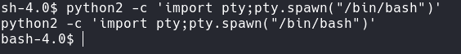Victim machine:

Kali Machine:

Victim:

I did look around for a bit and found nothing really of interest.

## Kernel Exploit

This one didn’t work.

After quite some time I found: <https://www.exploit-db.com/exploits/15285>



# A screen shot of a computer Description automatically generatedFlag